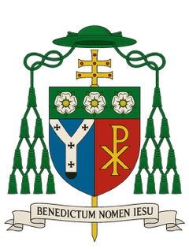

A Pastoral Message on the Occasion of the World Day of Prayer for the Care of Creation and the March for Life 2026

Dear brothers and sisters in Christ

At the beginning of September, we are invited to mark two important occasions in the life and witness of the Church. On Tuesday, 1 September, we observed the World Day of Prayer for the Care of Creation; and, on Saturday, 5 September, many will gather in London for the March for Life, to bear peaceful and public witness to the dignity of human life from conception until natural death.

These two occasions concern different questions, but they arise from the same truth of our faith: all that exists comes from God.

‘The earth is the Lord’s and all that is in it.’ (Ps. 24:1) Creation is a gift we receive from God. We do not worship creation; we worship the Creator. Creation bears the marks of God and points beyond itself to the Creator. Contemplating the beauty of creation, St Augustine asks: ‘Who made them if not the Beautiful One who is not subject to change?’

St Paul reminds us that all things were created through Christ and for Christ. (cf. Col. 1:16) A proper care for creation, rightly understood, does not lead us away from the Creator, but leads us more deeply into gratitude, reverence, and obedience towards God who made us. We are each called to be faithful stewards of creation who, in justice, preserve it for future generations.

Pope Benedict XVI spoke of the earth as a precious gift of the Creator, entrusted to our responsible stewardship. He warned against two opposite errors: treating nature as something to be exploited without restraint, and treating nature as though it had an absolute value apart from God, or even greater than the unique dignity of the human person.
This year, our Holy Father Pope Leo XIV has taken the words of the Prophet Isaiah as the theme for the World Day of Prayer for the Care of Creation: ‘They shall beat their swords into ploughshares and their spears into pruning hooks.’ (Is. 2:4) It is a striking image of peace and also of restoration. War wounds human beings, families and communities. It scars the land on which people depend for their livelihood. Violence, greed, exploitation, and the misuse of power all drive wars that damage both human relationships and the world which God has entrusted to us.

St Paul writes that ‘the whole creation has been groaning in labour pains.’ (Rom. 8:22) Creation groans because our world bears the consequences of sin. When our relationship with God becomes disordered, so do our relationships with one another. The greed, waste, violence, and selfishness that push us away from God not only harm creation, but also have damaging consequences for people who are poor and vulnerable and, so often, amongst the first to suffer.

This is why care for creation cannot be reduced simply to policy, technology, or good intention. It calls first for conversion, for us to remember that we are creatures - not the Creator - and that the world is a gift, not a possession.

Yet the Christian understanding of creation cannot stop there. Pope Benedict XVI memorably wrote that ‘the book of nature is one and indivisible.’ We cannot speak seriously about safeguarding creation whilst treating human life as disposable. The same God who created the heavens and the earth creates every human person in his image and likeness. (cf. Gen. 1:27)

Pope Francis made this connection in Laudato si’: ‘Since everything is interrelated,’ he wrote, ‘concern for the protection of nature is also incompatible with the justification of abortion.’ In defending the dignity of the natural world, how can we not defend human life when it is at its smallest, most dependent, and most defenceless?

This brings us to the March for Life on 5 September, whose theme this year is Abortion Hurts the Family. We are a people of life. Life is sacred and a gift from God. The measure of a humane society cannot be how readily it removes those whose presence it regards as a burden, but how generously it protects and accompanies them.

To defend the unborn child cannot mean abandoning or condemning a mother who is frightened or in difficulty. Both lives matter. Our defence of life must always be accompanied by compassion, practical help, friendship, forgiveness, and hope. We want to care for a mother and child together, support fathers and families, and offer healing to those who carry the pain of abortion.

Our concern for human dignity does not end at birth. The love of Christ and the love of our neighbour require us to defend human life, to protect human dignity, and to work for justice and peace, exercising proper care for the world in which God has placed us. These concerns belong together because they spring from our obedience to the one God who is Creator and Lord.

We are not the authors of creation; God is. Our task is to receive his gifts with gratitude, to recognise the order he has placed within creation, and to seek his will rather than our own. We are called to cherish what God has entrusted to us; to stand beside those whom the world is tempted to overlook or discard; and to hand on his gifts faithfully to those who will come after us.

Let us pray in thanksgiving for the beauty and goodness of God’s creation, and ask forgiveness for the ways in which we have damaged or misused it. Let us pray and witness peaceably for unborn children, their mothers, fathers, and families. Let our prayer be simple and clear: Lord, teach us to know and do your will.

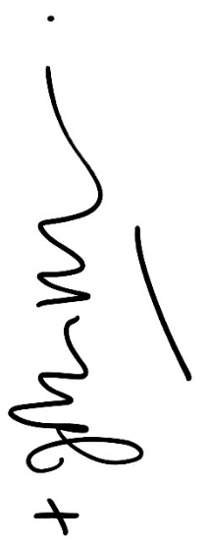
May the Holy Spirit, the Lord and Giver of Life, renew the face of the earth, renew our hearts, and make us faithful witnesses to the dignity, beauty, and goodness of all that God has made.

With every blessing and the assurance of my prayers

Most Rev John Wilson
Archbishop of Southwark

Given at Southwark on 4 September 2026

Sermo 241, 2; cf. Catechism of the Catholic Church, 32.
Caritas in veritate, 48, 51; Message for the World Day of Peace 2010, 13–14.
Caritas in veritate, 51
Laudato si’, 120

